**NAME: SARANYA.M**

**DEPARTMENT: B.E BIOMEDICAL ENGINEERING**

**COLLEGE: DHANALAKSHMI SRINIVASAN INSTITUTE OF TECHNOLOGY SAMAYAPURAM , TRICHY.**

**NAANMUDHALVAN COURSE: DIGITAL MARKETING**

**NM ID: FEC12536FCF0271BF654C25C25FD1AD0**

**ASSIGNMENT ON DIGITAL MARKETING**

1. **Create a blog or website using BlogSpot and WordPress. Customize the theme design and post new article with 500 words.**

**WordpressURL:**  **https://fashioini.wordpress.com/2023/10/16/fashionista/**

**Blogger**[**URL:https://www.blogger.com/u/2/blog/posts/6333525472747336539?pli=1#crete**](URL:https://www.blogger.com/u/2/blog/posts/6333525472747336539?pli=1#crete)

1. **Create a new Facebook business page and post one social media poster for your brand.**

[www.facebook.com/**SAGODESIGNERS**](http://www.facebook.com/SAGODESIGNERS) **- Facebook URL**

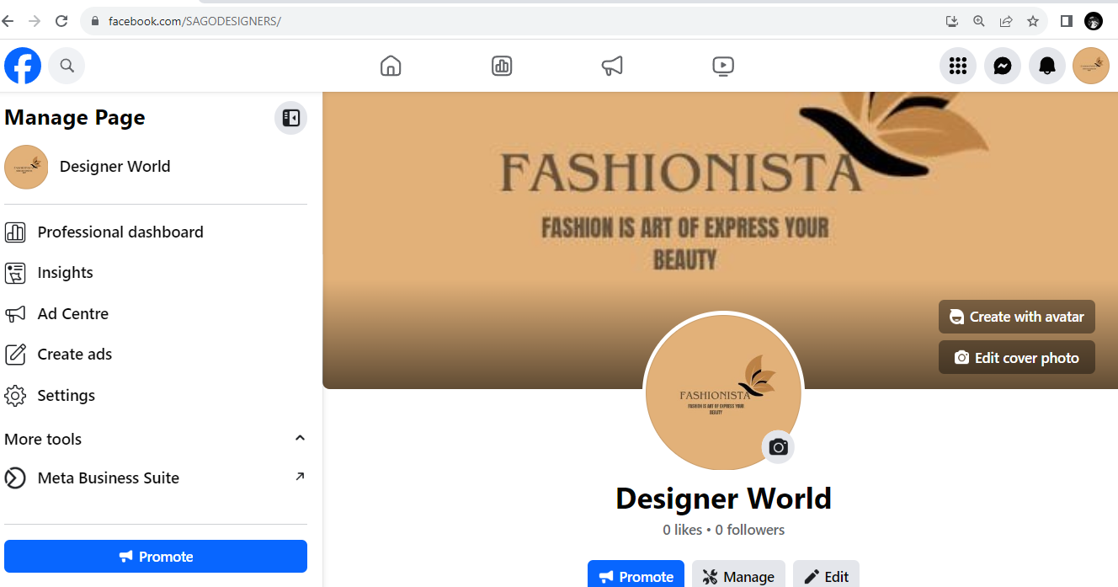

1. **Create and design a social media advertisement poster using canva**

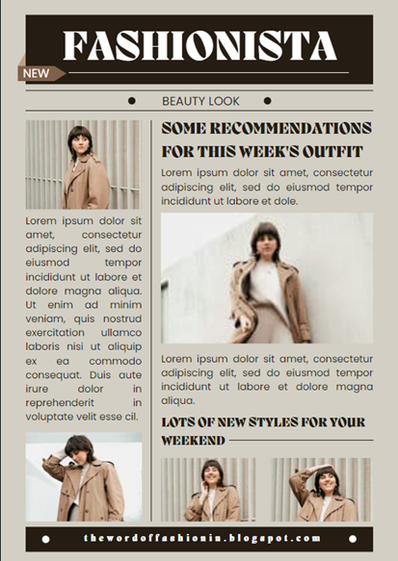

1. **Create email newsletter design using Mail chimp or canva tool.**

